 | 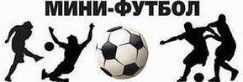 |  |  |  |  |  |  |  |  |  |  |  |  | 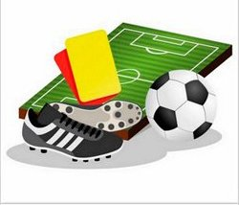
 |  |  |  |  | 0-12 | 1-12 | 8-6 | 3-3 | 2-6 | 2-6 | 1 | 1 | 4 |  | 4 | 16/45 | 6
 |  |  |  |  | 0 | 0 | 3 | 1 | 0 | 0 |  |  |  |  |  | -29
 |  |  |  | 12-0 |  | 3-5 | 3-4 | 15-4 | 6-1 | 4-1 | 4 | 0 | 2 |  | 12 | 43/15 | 2
 |  |  |  | 3 |  | 0 | 0 | 3 | 3 | 3 |  |  |  |  |  | +28
 |  |  |  | 12-1 | 5-3 |  | 8-3 | 17-1 | 4-2 | 11-1 | 6 | 0 | 0 |  | 18 | 57/11 | 1
 |  |  |  | 3 | 3 |  | 3 | 3 | 3 | 3 |  |  |  |  |  | +46
 |  |  |  | 6-8 | 4-3 | 3-8 |  | 8-0 | 3-6 | 6-1 | 3 | 0 | 3 |  | 9 | 30/26 | 4
 |  |  |  | 0 | 3 | 0 |  | 3 | 0 | 3 |  |  |  |  |  | +4
 |  |  |  | 3-3 | 4-15 | 1-17 | 0-8 |  | 1-13 | 4-5 | 0 | 1 | 5 |  | 1 | 13/61 | 7
 |  |  |  | 1 | 0 | 0 | 0 |  | 0 | 0 |  |  |  |  |  | -48
 |  |  |  | 6-2 | 1-6 | 2-4 | 6-3 | 13-1 |  | 10-0 | 4 | 0 | 2 |  | 12 | 38/16 | 3
 |  |  |  | 3 | 0 | 0 | 3 | 3 |  | 3 |  |  |  |  |  | +22
 |  |  |  | 6-2 | 1-4 | 1-11 | 1-6 | 5-4 | 0-10 |  | 2 | 0 | 4 |  | 6 | 14/37 | 5
 |  |  |  | 3 | 0 | 0 | 0 | 3 | 0 |  |  |  |  |  |  | -23

